(EXTRA) 1.6 –Graphing Absolute Value Equations and Inequalities

Graphing Absolute Value Functions;
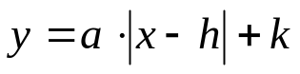:
- Vertex: (h, k)
- Line of Symmetry: x = h
- a = SLOPE of graph RIGHT of the line of symmetry
- The graph is V-shaped
(Symmetric about line of symmetry)
- Opens up if a > 0 and down if a < 0

GeoGebra Example

Steps to Graphing Absolute Value Functions:
- Graph the vertex (h, k)
- Plot 1 point to the right of the line of symmetry using slope = a
- Plot the corresponding symmetric point on the left side of the line of symmetry
- Complete the graph

Examples:
Graph the function.
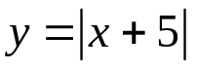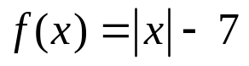

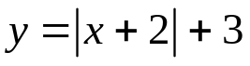

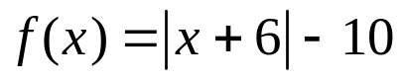

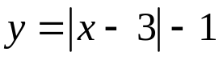

Graphing Absolute Value Functions;
:
- If 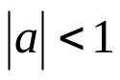, then the graph of 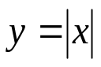 is wider
- If 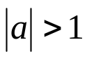, then the graph of is narrower

Steps to Graphing Absolute Value Functions:
- Graph the vertex
- Plot two points to the right of vertex using “slope” = a
- Plot the corresponding symmetric points to the left of vertex
- Complete the graph

Examples: Graph the following
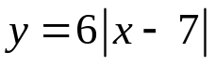

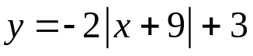

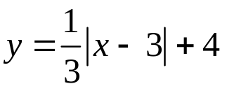

Write the equation of the graph shown:
